Introducing PDF Style Reporting and Copy to LIMS

In many situations it is necessary to send MassHunter Quantitative Analysis batch reports in the form of csv files directly to a LIMS system. This brief utilizes a pdf style report to generate a csv file and copy the csv file to a LIMS based server system.

I. Create and Edit the Post Process Script

- Click the Edit Post Process button in the lower right hand corner, then click New.

- In the Post Process task window fill the Task name as LIMS.
- Enter D:\MassHunter\Scripts\Quant\Report\QuantReportPostProcess-CopyCSVFile.bat into the Executable file field.
- In the Arguments field type: $(DestinationFilePath) as indicated in the Post Process window.
- Click OK and Close.

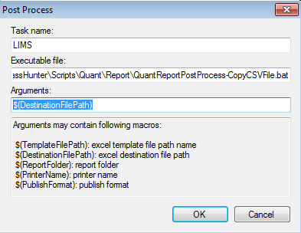

- In the Report Method Edit task window, select Post Process as LIMS for the script just named.

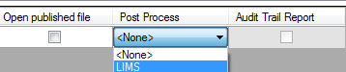

- Before exiting from the Report Method task window, review the information in the Results tab. If not already chosen, select the correct Instrument Type and select Auto.

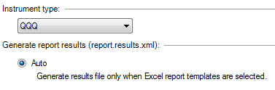

- Under FileSave Method As and give an appropriate name. Note the location of this method. Or as an option select Save & Exit button.
- Exit and generate a report.
- The default path for the copy to LIMS is C:\Temp. An original copy of the csv is retained in the Report folder and a copy is placed in this directory. See the next section on the procedure to edit the default location.

II Editing the Default Location
The default file location is C:\Temp. To change this location to a mapped network drive or server:

- Make a back-up copy of D:\MassHunter\Scripts\Quant\Report\ QuantReportPostProcess-CopyCSVFile.bat.
- Open Notepad or another suitable text editor.
- Go to FileOpen and select D:\MassHunter\Scripts\Quant\Report\ QuantReportPostProcess-CopyCSVFile.bat.
- While retaining the same syntax change the c:\temp\, to the mapped network LIMS server file location in the two line indicated below. Remember to retain the trailing ‘\’.
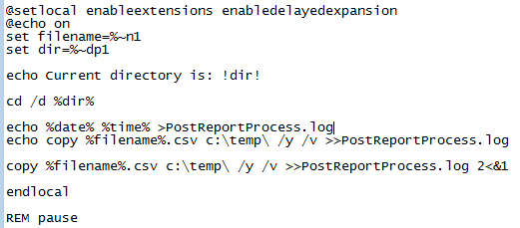

- After the changes have been made, FileSave the FileExit to close Notepad.

