Printer Setup for a Client/Server system
Make sure the printer is in the control panel of a Windows Print Server or on the OpenLab Shared Services Server (OLSS)
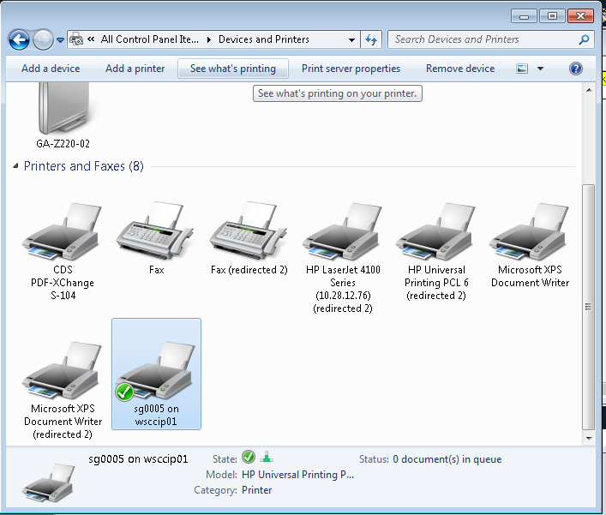
On the OLSS in the administration printer’s menu, add a monitor folder pointing to the selected printer.
After setting up the printer be sure to set Monitor to on.
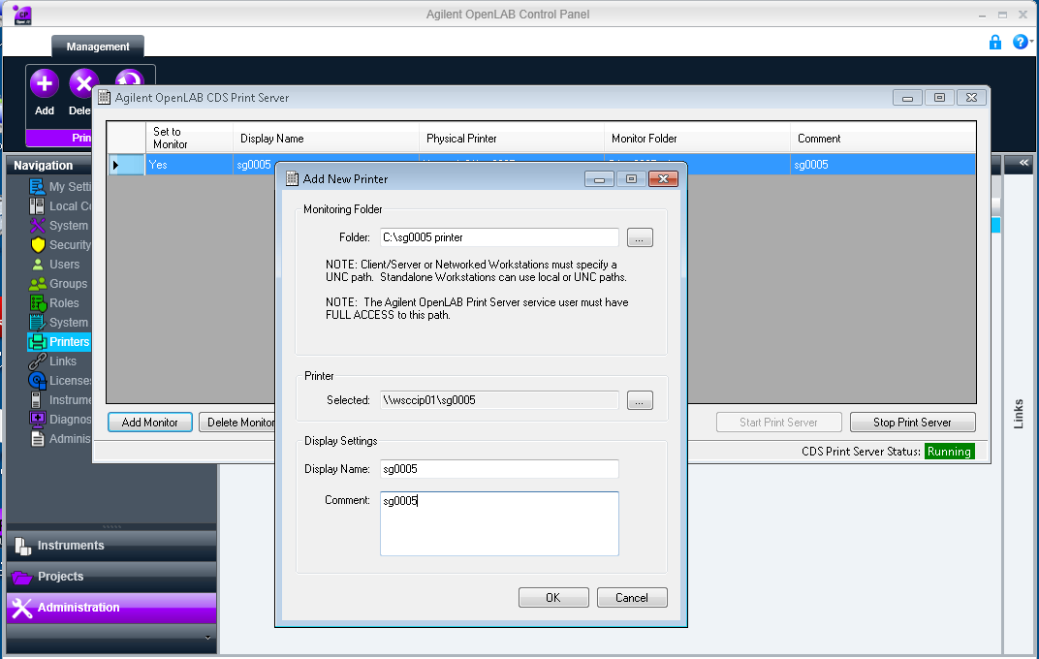
Again, on the OLSS in the services tab of computer management, edit the OpenLABCDSPrintServer.
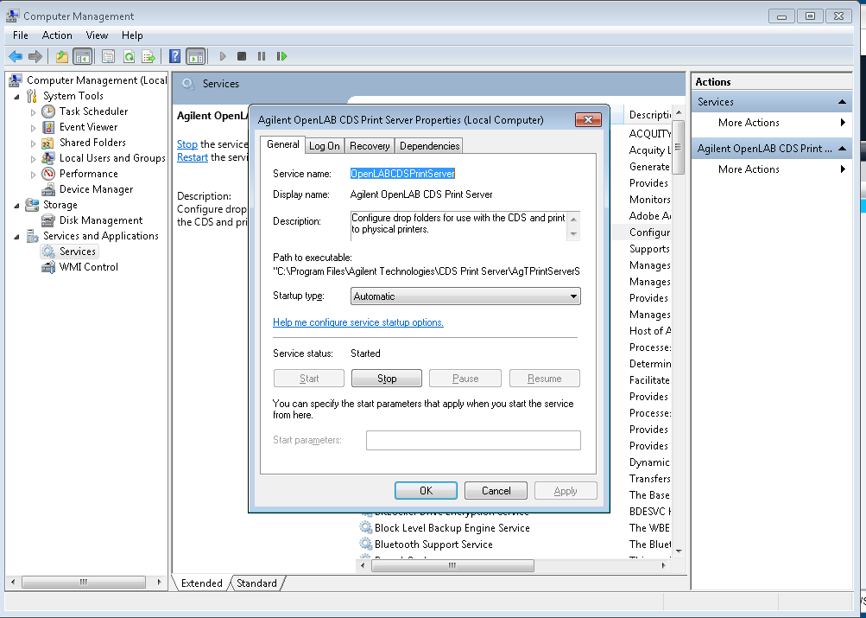
Log on as an admin user. Restart the service.
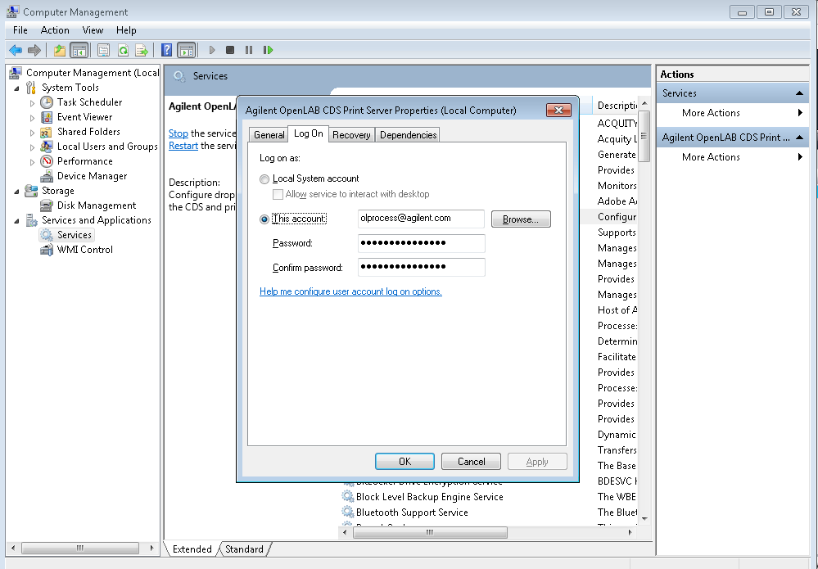
Before setting an instrument to the new printer be sure to drop a pdf into the shared folder of the new printer to verify it is set up properly.
Associate the printer configuration with the instrument.
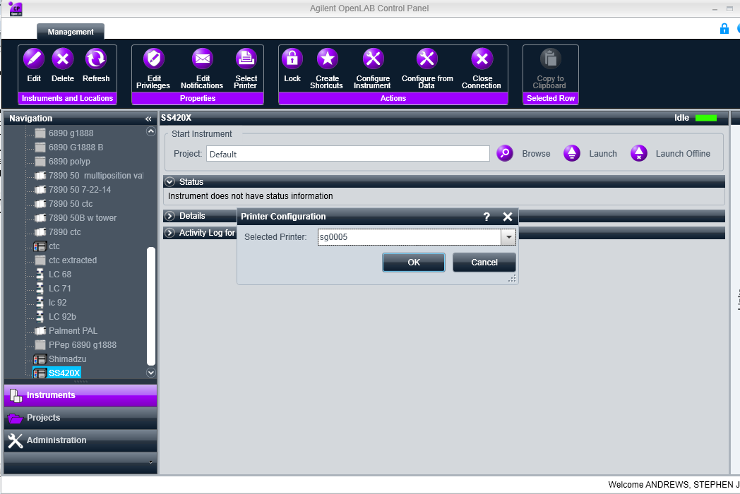
Select print hardcopy. Automatic printing only occurs with real time acquisition.
