Attachments: Missing Firmware for G6691A Flow Meter and G6693A Leak Detector

Leak Detector in Calibration Mode
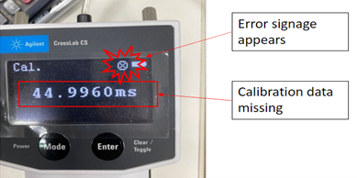

Flow Meter in Calibration Mode
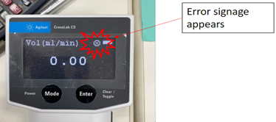

Error/Warning Screen
