

RapID Raw Materials Verification System

Quick Start Model Building Guide



Contents

Method Creation 4

Settings selection 6

Clear Bags 6

Zero settings 6

Offset Settings 6

Opaque Plastic Containers 7

Paper Sacks 8

Glass Container 11

Scan selection and model build 14

Identifying Valid Spectra 15

Obtain reference spectra 15

Viewing Zero and Offset 15

Container Reference Spectra 16

White HPDE 16

Blue HDPE 16

Colorless Glass 17

Amber Glass 17

Paper bag 18

FIBC 18

Ambient Light Spectra 19

Mercury Argon Tube Lighting 19

Krypton Tube Lighting 20

Daylight and Room Light 20

Assessing Spectrum Quality 21

Failing Validation – How to Proceed 22

Figure 1: Main Menu, Create library 4

Figure 2: Create Library Page, non-unique library name 4

Figure 3: Create Library Page, unique library name 4

Figure 4: Create Library, Training page 5

Figure 5: Create Library, Edit Collection Settings 5

Figure 6: Create Library, Settings page 5

Figure 7: Setting Selection for Clear Bags 6

Figure 8: Setting Selection for Opaque Plastic Containers 7

Figure 9: Setting Page 8

Figure 10: Training page with Settings Button Flashing Red 9

Figure 11: Settings to be updated for paper bag/ Software recommendation 9

Figure 12: Settings to be updated for paper bag/ Software recommendation matches user input 10

Figure 13: Settings to be updated for paper bag/ Flagged Settings 10

Figure 14: Settings Page 11

Figure 15: Training Page with settings flashing in red 12

Figure 16: Settings to be updated for amber bottle/ Software recommendation 12

Figure 17: Settings to be updated for amber bottle/ Software recommendation matches user input 12

Figure 18: Settings to be updated for paper bag/ Flagged Settings 13

Figure 19: Training page with built model, ready for validation 14

Figure 20: Training page, view Z&O highlighted 15

Figure 21: Measurement page, Z&O baselined spectra 15

Figure 22: White HDPE only reference Raman spectrum 16

Figure 23: Blue HDPE only reference Raman spectrum 16

Figure 24: Colorless glass only reference Raman spectrum 17

Figure 25: Amber glass only reference Raman spectrum 17

Figure 26: Paper bag only reference Raman spectrum 18

Figure 27: FIBC only reference Raman spectrum 18

Figure 28: Mercury Argon tube lighting spectrum 19

Figure 29: Ambient Light Algorithm 19

Figure 30: Krypton tube lighting spectrum 20

Figure 31: Daylight and room light spectrum 20

Figure 32: Low SNR scan 21

Figure 33: Improved SNR scan 22

Figure 34: Edit Library Selection 22

Figure 35: Rejected Library Status 23

Figure 36: Copy Validated library 23

# Method Creation

An expert level user can select ‘Create Library’ to enter the model building ‘Training’ window

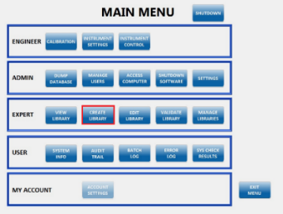

Figure : Main Menu, Create library

Enter the Library details on the create library screen, the contents name is copied down automatically to the library name. The library must be unique so if used before will be surrounded in pink (as shown).

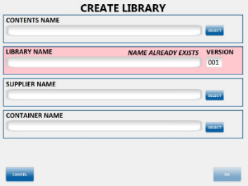

Figure : Create Library Page, non-unique library name

If a unique library name is entered, then the box becomes green.

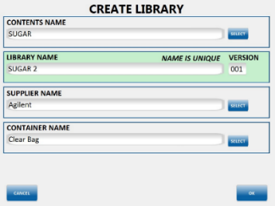

Figure : Create Library Page, unique library name

Upon clicking on ‘OK’, the ‘Training’ window launches and then the user can adjust the model build settings by selecting the ‘Settings’ tab

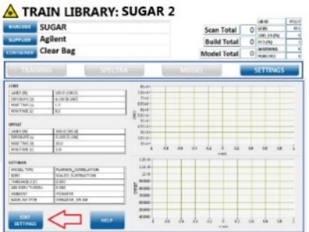

Figure : Create Library, Training page

Click the ‘Edit Settings’ button at the bottom

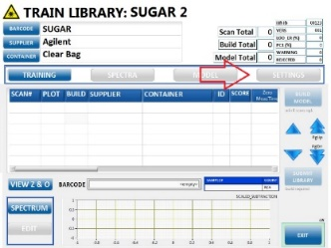

Figure : Create Library, Edit Collection Settings

The ‘Settings’ page opens up

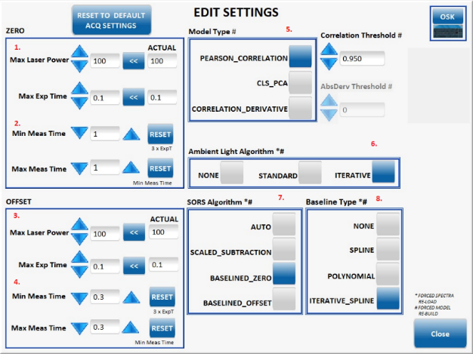

Figure 6: Create Library, Settings page

# Settings selection

## Clear Bags

## Zero settings

1. Leave Max Laser Power and Exp. Time as default.

2. Set Min. and Max. Meas. Time to 1 second, this measurement time should not require increasing.

## Offset Settings

3. Leave Max Laser Power and Exp. Time as default.

4. Set Min and Max Meas. to lowest value (0.3 seconds).

5. Default Model Type is Pearson which is used for the majority of libraries. Correlation Derivative model type should be employed for materials of similar chemistry, to eliminate false matches.

6. Iterative Light is the most widely used Ambient Light Algorithm and is well suited to the typical warehouse environment. Consider using Standard if sunlight is present.

7. Baselined Zero is suitable for SORS algorithm for this type of container.

8. Iterative Spline is the default baseline type, Spline is also a valid choice, avoid Polynomial.



Figure : Setting Selection for Clear Bags

## Opaque Plastic Containers

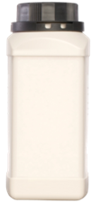**Zero settings**

1. Leave Max Laser Power and Exp Time as default.

2. Set Min and Max Meas. Time to 1 second.

**Offset Settings**

3. Leave Max Laser Power and Exp. Time as default.

4. Start with measurement time Min and Max set to 10 seconds, if resultant spectrum has low SNR and count rate sub 6000 then increase Min/Max by 5 seconds increments. For measurement time >30 seconds, set Max Exp. Time to 0.2 seconds.

5. Default Model Type is Pearson which is used for the majority of libraries. Correlation Derivative model type should be employed for materials of similar chemistry, to eliminate false matches.

6. Iterative Light is the most widely used Ambient Light Algorithm and is well suited to the typical warehouse environment. Consider using Standard if sunlight is present.

7. Scaled Subtraction is required for SORS algorithm for this type of container.

8. Iterative Spline is the default baseline type. Spline is also a valid choice, avoid Polynomial.

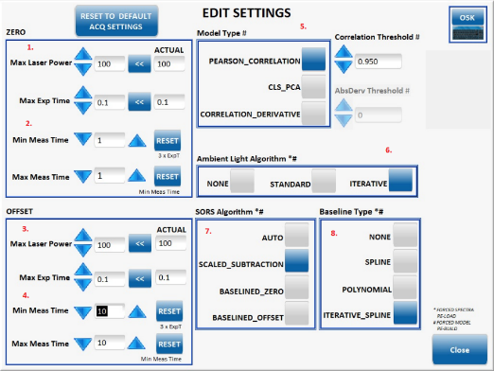

Figure : Setting Selection for Opaque Plastic Containers

## Paper Sacks

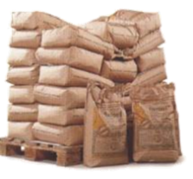**Zero Settings –**

1. Leave Max Laser Power and Exp. Time as default. The instrument will adjust those values to avoid saturation.

2. Set Min and Max Meas. Time to 1 second.

**Offset Settings --**

3. leave Max Laser Power and Exp Time as default.

4. Set Min and Max Meas. Time to 20 seconds as a starting point. if resultant spectrum has low SNR and count rate sub 6000 then increase Min/Max by 5 seconds increments. For measurement time >30 seconds set Max Exp. Time to 0.2 seconds.

5. Default Model Type is Pearson which is used for the majority of applications. Correlation Derivative model type should be employed for materials of similar chemistry, to eliminate false matches.

6. Iterative Light is the most widely used Ambient Light Algorithm and is well suited to the typical warehouse environment. Consider using Standard if sunlight is present.

7. Scaled Subtraction is most suited for SORS algorithm to this type of container

8. Iterative Spline is the default baseline type, Spline is also a valid choice, avoid Polynomial.

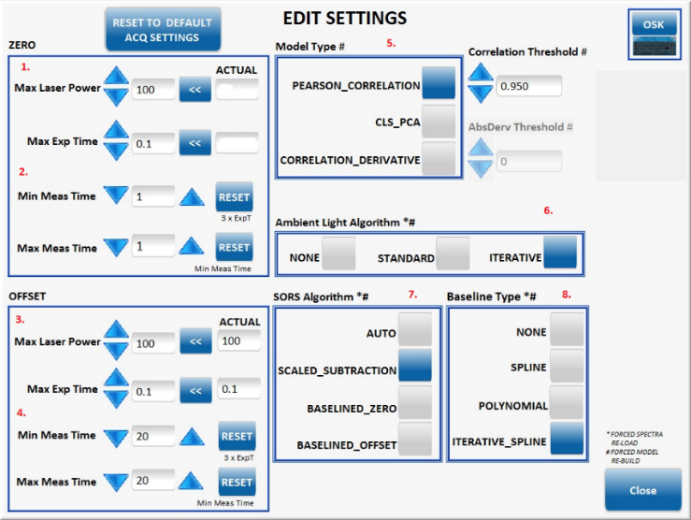

Figure : Setting Page

Following acquisition of the first scan the settings box will probably flash with a red border. This indicates that the instrument has adjusted the laser power and/or exposure time.

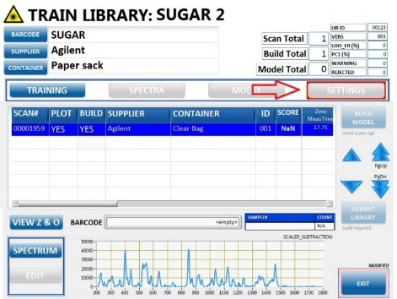

Figure 10: Training page with Settings Button Flashing Red

Please open settings again and observe the values under the ‘Actual’ heading. These are the settings that the instrument selected. These should be copied across to settings box using the  button. The instrument will then start with these settings when performing the new scan.

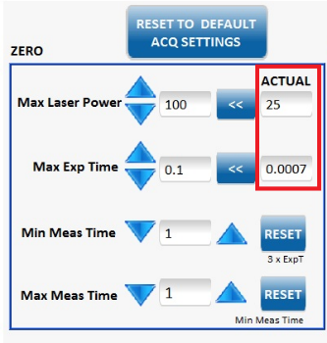

Figure 11: Settings to be updated for paper bag/ Software recommendation

Following pressing the  the Max laser power and Max Exp. Time now match the Actual values boxes

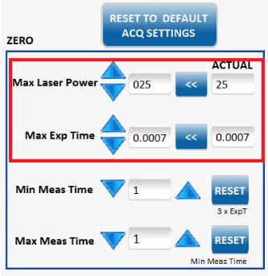

Figure 12: Settings to be updated for paper bag/ Software recommendation matches user input

If for the following scan, the settings box flashes red again, the user should consider using the following Zero settings for paper and glass:

Max Laser Power: 40%

Max Exp. Time : 0.0015 seconds

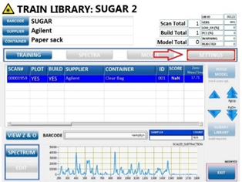

Figure 13: Settings to be updated for paper bag/ Flagged Settings

## Glass Container

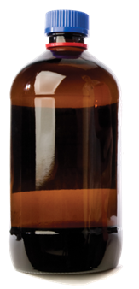**Zero Settings –**

1. Leave Max Laser Power and Exp. Time as default. The instrument will adjust those values to avoid saturation.

2. Set Min and Max Meas. Time to 1 second.

**Offset Settings --**

3. Leave Max Laser Power and Exp. Time as default.

4. Set Min and Max Meas. Time to 10 seconds as a starting point for clear glass and 20 seconds as a starting point for amber glassware. If resultant spectrum has low SNR and count rate <6000 then increase Min/Max by 5 seconds increments. For measurement time >30 seconds set Max Exp. Time to 0.2 seconds

5. Default Model Type is Pearson which is used for the majority of libraries. Correlation Derivative model type should be employed for materials of similar chemistry, to eliminate false matches.

6. Iterative Light is the most widely used Ambient Light Algorithm and is well suited to the typical warehouse environment. Consider using Standard if sunlight is present.

7. Scaled Subtraction is the most suited for SORS algorithm to this type of container; Baselined Offset can also be used but generally results in greater noise in the resultant spectrum.

8. Iterative Spline is the default baseline type, Spline is also a valid choice, avoid Polynomial.

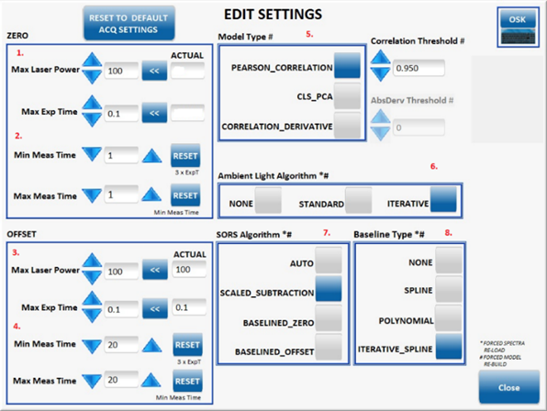

Figure 14: Settings Page

Following acquisition of the first scan the settings box may flash with a red border. This indicates that the instrument has adjusted the laser power and/or exposure time. This does not always occur with glassware.

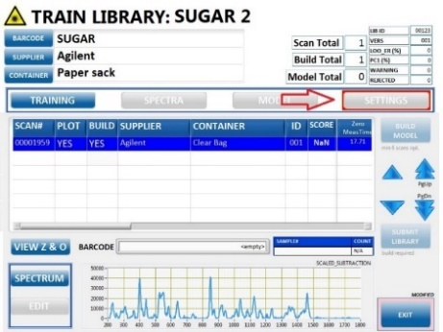

Figure 15: Training Page with settings flashing in red

If the settings box does flash, open settings again and observe the values under the ‘Actual’ heading. These are the settings that the instrument selected. These should be copied across to settings box using the  button. The instrument will then start with these settings when performing the new scan.



Figure 16: Settings to be updated for amber bottle/ Software recommendation

Following pressing the  the Max laser power and Max Exp Time now match the Actual values boxes.



Figure 17: Settings to be updated for amber bottle/ Software recommendation matches user input

If following the next scan the settings box flashes red again, the user should consider using the following Zero settings for the glassware:

* Max Laser Power: 40%
* Max Exp Time: 0.0015 seconds



Figure 18: Settings to be updated for paper bag/ Flagged Settings

# Scan selection and model build

1. Scan the sample once and evaluate the quality of the data, if poor SNR and count rate is low, make adjustments to settings as described previously.
2. Collect the Min number of scans displayed under the Build Model button, you may typically collect up to 20 -30 scans when building, depending on SOP requirements.
3. Press the Build Model button.
4. The result is shown in the Build column, Green signifies that this result should be included in the model (user should set to YES), Pink and Yellow should not be included (user should set to NO).
5. Once satisfied with the data quality and assuming all scans selected are Green, Press the build button and then submit the Library.

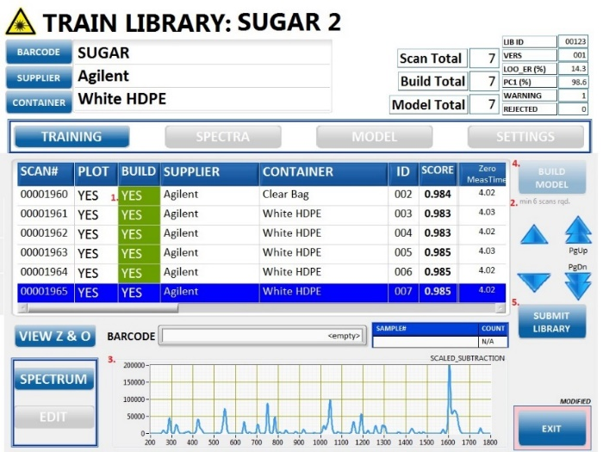

Figure 19: Training page with built model, ready for validation

# Identifying Valid Spectra

## Obtain reference spectra

If the user is unsure whether the resultant SORS spectrum is representative of the contents, he/she should consider obtaining container only reference measurements or a scan of the contents within a clear glass vial or clear bag. These scans can be obtained at the Training stage and any scans acquired, excluded from the model build.

## Viewing Zero and Offset

In the absence of reference spectra, it is often useful to view the Zero and Offset Spectra to determine if the reported SORS spectrum is representative of the sample contents. Press the View Z & O button within the Training window to view the separate zero and offset scans.

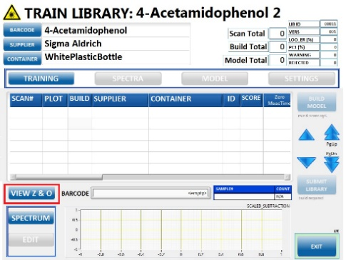

Figure 20: Training page, view Z&O highlighted

The Zero spectrum (shown in blue) should have a large proportion of container signal and much lower proportion of contents signal, whereas the Offset spectrum (shown in red) should be dominated by contents.

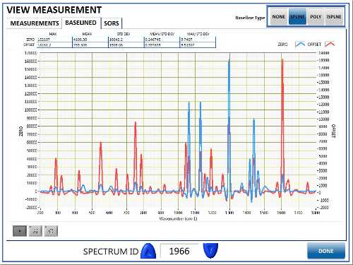

Figure 21: Measurement page, Z&O baselined spectra

Through barrier SORS measurements should display a significant contrast between zero and offset spectra unless the container used is a clear bag. If both spectra appear the same then it is probable that the through barrier scan has not successfully revealed the contents spectrum.

## Container Reference Spectra

The following are reference spectra associated with common container types. These can be used to determine if the resultant SORS spectrum is representative of the container rather than the contents. It is still possible to build a viable model, even with significant container signal present, providing that the contents is represented within the spectrum and the signal is stable and consistent between repeat measurements.

### White HPDE

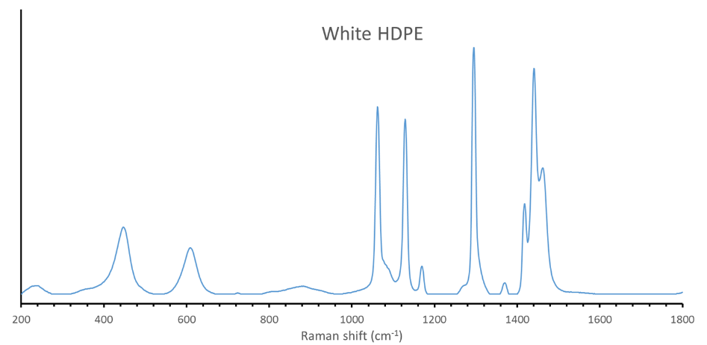

Figure 22: White HDPE only reference Raman spectrum

Note the two bands ~450 cm-1 and ~600 cm-1 the characteristic Raman bands of the white pigment, TiO2. These bands are not present for clear HDPE containers. The 4 strong features between 1000 and 1500 cm-1 are representative of PE.

### Blue HDPE

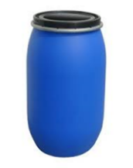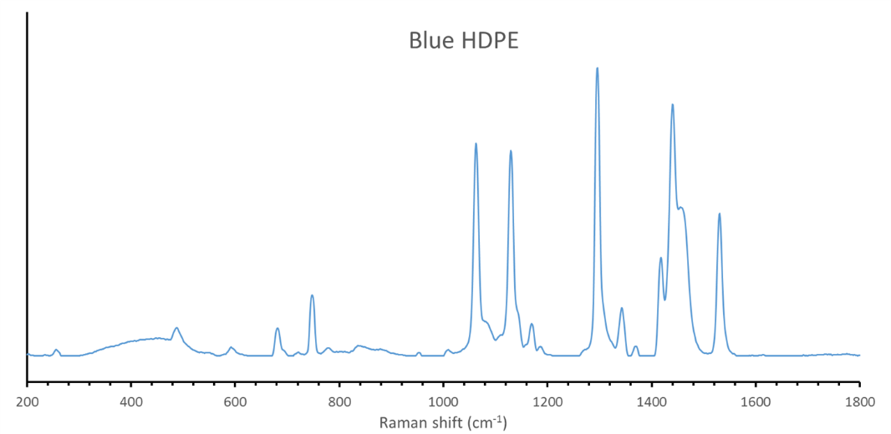

Figure 23: Blue HDPE only reference Raman spectrum

Note the strong band ~1550 cm-1 and peaks between 500 cm-1 and 800 cm-1 from the blue pigment. This container type is quite challenging and often SORS is not able to extract the container signal.

### Colorless Glass

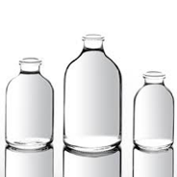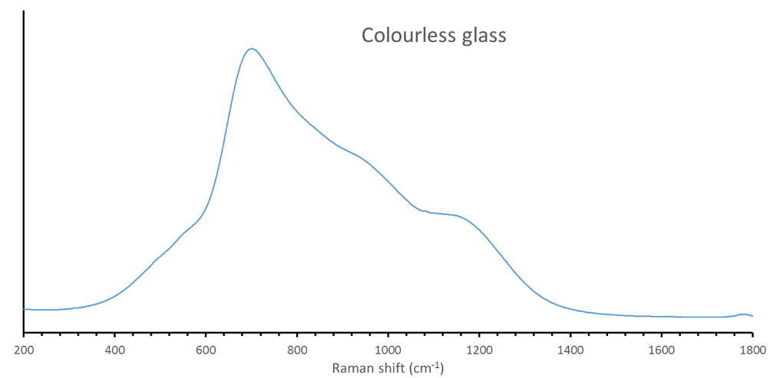

Figure 24: Colorless glass only reference Raman spectrum

### Amber Glass

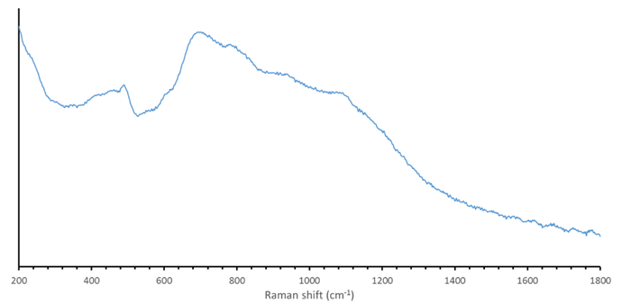

Figure 25: Amber glass only reference Raman spectrum

Note that glass has an intense fluorescence signal caused by the excitation of trace metal ions in the chemical composition. These containers contribute little to the SORS spectrum and have no defined spectral features, thus any peaks in the SORS spectrum can be assigned to the contents. Therefore, they are good containers within which to obtain a reference spectrum.

### Paper bag

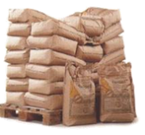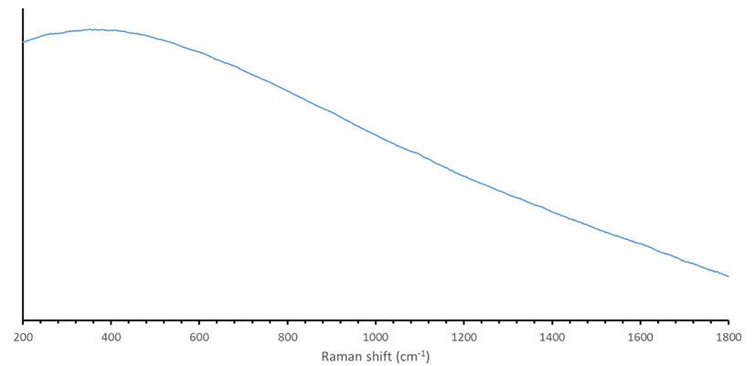

Figure 26: Paper bag only reference Raman spectrum

Note that the intense fluorescence masks any spectral features associated with cellulose.

### FIBC

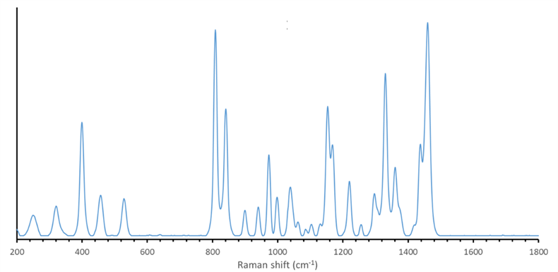

Figure 27: FIBC only reference Raman spectrum

Note that FIBC Raman spectrum is mostly displaying spectral features associated with the PP material. These are not particularly challenging container types and so it is uncommon to see these container features within the SORS spectrum.

## Ambient Light Spectra

The following are examples of ambient light spectra. RapID measures that ambient light and attempts a subtraction from the SORS contents spectrum. However, if the contents is a very weak scatterer or the container has high translucency then the following Raman bands are commonly observed.

### Mercury Argon Tube Lighting

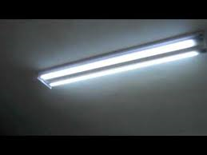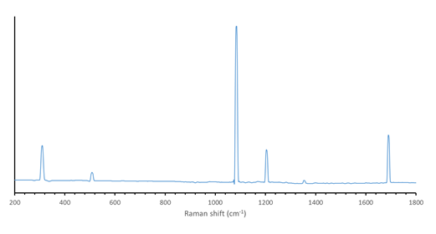

Figure : Mercury Argon tube lighting spectrum

Characteristic sharp features with the largest peak at 1080 cm-1. Consider using the Iterative light algorithm within Training settings.

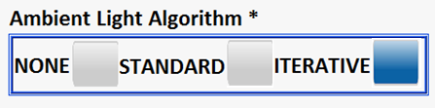

Figure : Ambient Light Algorithm

### Krypton Tube Lighting

[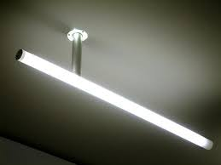](https://www.google.com/imgres?imgurl=https%3A%2F%2Fwww.torchstar.us%2Fmedia%2Fwysiwyg%2F333.jpg&imgrefurl=https%3A%2F%2Fwww.torchstar.us%2Ffrontnews%2Findex%2Fview%2Fid%2F129&docid=nuNU8alJUIsy0M&tbnid=QgYr7lg3nLesaM%3A&vet=10ahUKEwjL7M6p5sbkAhXOop4KHbQLBBEQMwibASgWMBY..i&w=550&h=413&bih=651&biw=1371&q=krypton%20tube%20lighting&ved=0ahUKEwjL7M6p5sbkAhXOop4KHbQLBBEQMwibASgWMBY&iact=mrc&uact=8)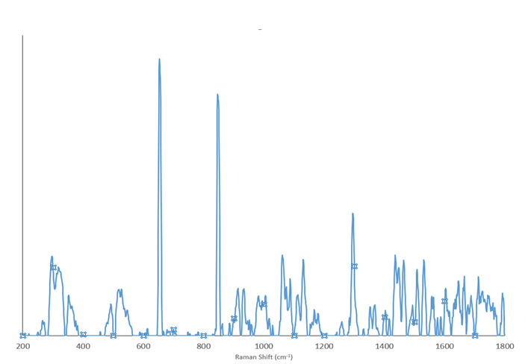

Figure : Krypton tube lighting spectrum

Characteristic sharp features with the largest peaks at 650 cm-1 and 850 cm-1. Consider using the Standard Light algorithm if the features remain very prominent with the Iterative light Algorithm.

### Daylight and Room Light

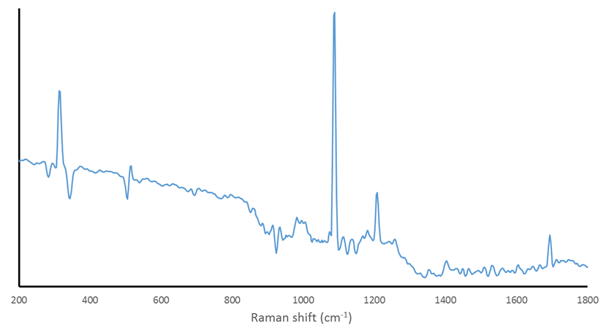

Figure : Daylight and room light spectrum

Sharp features associated with the tube lighting and negative peaks which are absorption features due to nitrogen and oxygen in the atmosphere.

If the sampling environment has a significant exposure to sun light, then consider using the Standard Light Algorithm.

# Assessing Spectrum Quality

In addition to confirming that the content (i.e. raw material) is sufficiently represented within the spectrum, the expert user must also consider the spectral quality of the collected spectra that will be used to build the model.

If possible, the user should adjust measurement time settings to ensure that the signal intensity of the largest Raman feature is in excess of 6000 counts, and, more importantly features a good Signal to Noise Ratio (SNR). Low SNR will result in a large amount of variability between measurements and will prevent the successful building of the model mean.

While acquiring data, the expert user will make iterative adjustments to the measurement time until sufficient quality spectra are obtained. This involves making a qualitative assessment of SNR prior to building and attempting to build the model periodically as further scans are added to the model build (once the minimum build number is obtained). If the measurement is a Baselined Zero measurement, only Zero measurement time increases will be required. For Scaled Subtraction measurements, only the Offset Min and Max time shall be increased. Values between scans shall be adjusted and spectral quality reviewed after each measurement. The same values for both Min and Max, e.g. Min 5 s and Max 5s, Min 10s and Max 10s etc should be used.

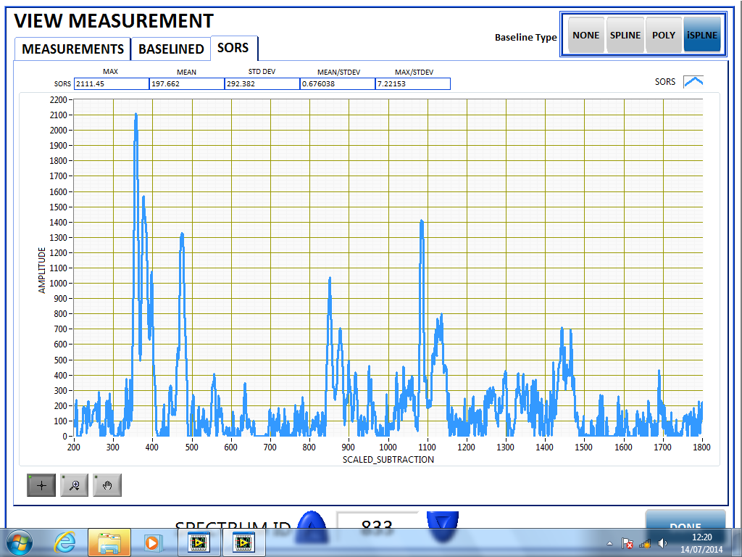

Figure 32: Low SNR scan

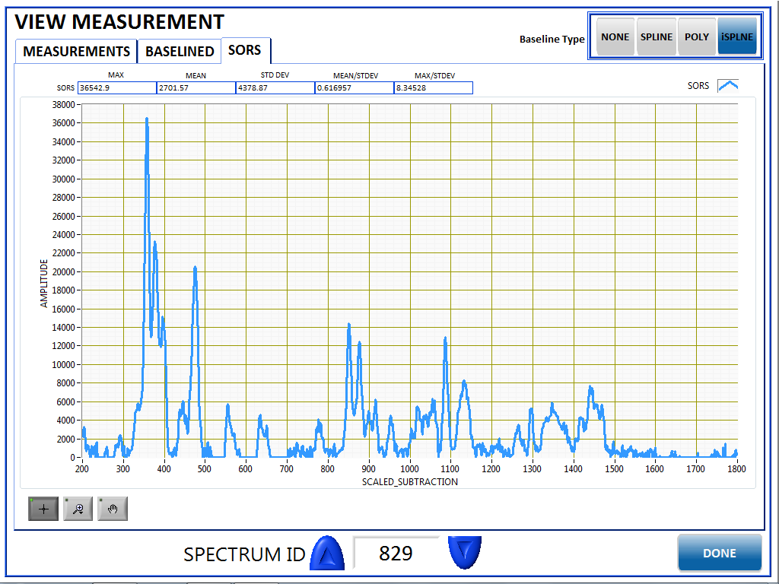

Figure : Improved SNR scan

# Failing Validation – How to Proceed

A RapID Library entry enters rejected status if the Validation stage is failed. The user should first select Edit Library and locate the library under Rejected status.

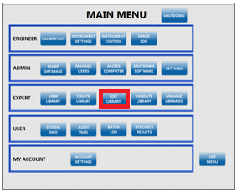

Figure : Edit Library Selection

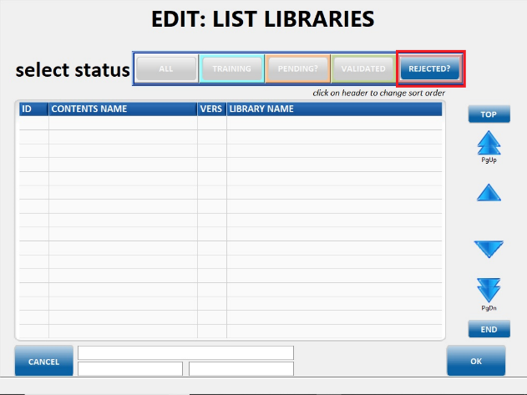

Figure : Rejected Library Status

The library can then be up-revisioned, incrementing the version number to version 2 and then sent to Training status for settings adjustment. The rejected library can be selected from the rejected list.

The Copy Validated library screen permits the user to enter a library name or use the existing library name. The user is invited to choose what happens to the existing validation data. Since the validation needs repeating it may be valid to select the ‘Ignore’ option.

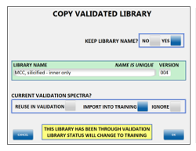

Figure : Copy Validated library

Once back in Training status, the user must consider whether the measurement quality can be improved by lengthening the appropriate measurement setting, or, if this is not possible the user may consider lowering the model threshold depending on the SOP requirements.