How to monitor 2 or more LCMS signals at the same time in OLCDS2.4
On the Method tab:
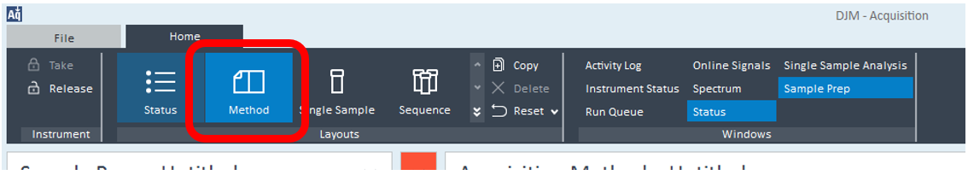

Make sure your Acquisition Parameters are set how you want them. Here I have 2 SIM ions (195.1 & 609.3m/z). Then in the Chromatograms section of the SQ method, and the Chrom Type you wish to monitor – here I chose EIC for both. Select the extracted mass you wish to observe in the Online plot and be as descriptive as possible in the Label – the default setting for EIC labels the plot as EIC and it could be tricky to distinguish which plot belongs to which ion:
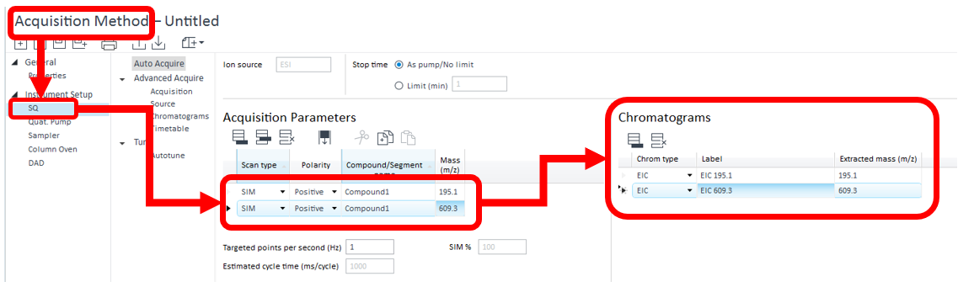

Remember that the Chromatograms section is part of the method, so be sure to Save the method (or Save As):
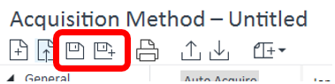

…..and then Download to the Instrument:
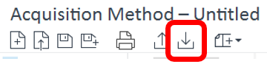

Then on the Status tab:
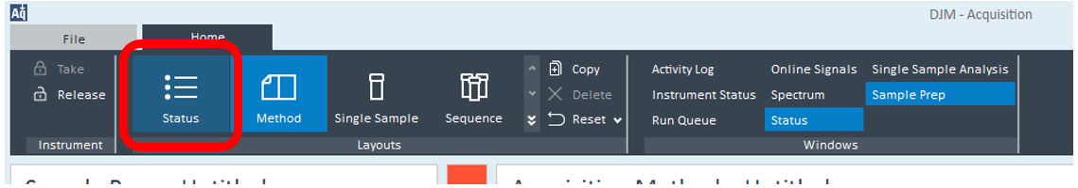
Goto Online Signals and the 2 chromatograms you set up previously should now be visible. I have shown them here as ‘Separate’ signals but you can have them ‘Overlaid’ if you prefer:
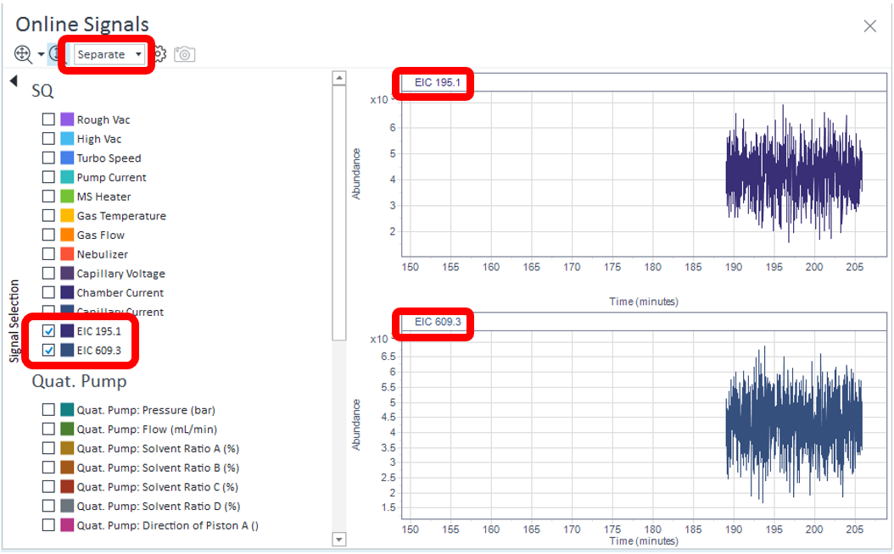

If you don’t see the Online Signals scroll up to the top of the screen and make sure the option is highlighted:
