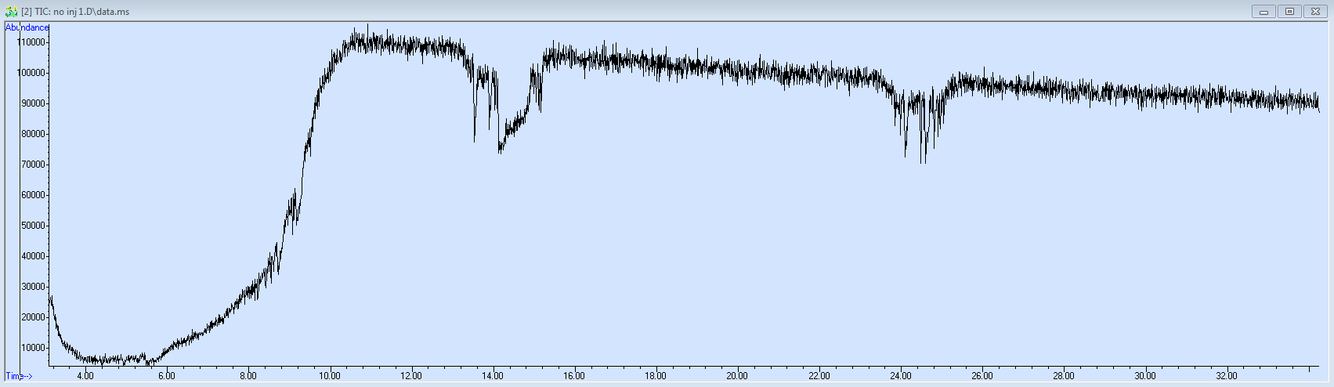
(Above) Oven ramp to 325 to check conditioning with needle off.
Then baked out MSD: 325’C source, 200’C quad, 2 hr bake.
Then loaded method and ran 3 times with needle off: inlet 250’C, oven start 150’C, hold one minute, ramp 21’C/min to 276’C hold, post run 325’C for 3 min. source=230’C, quad 150’C, transfer line 230’C.
